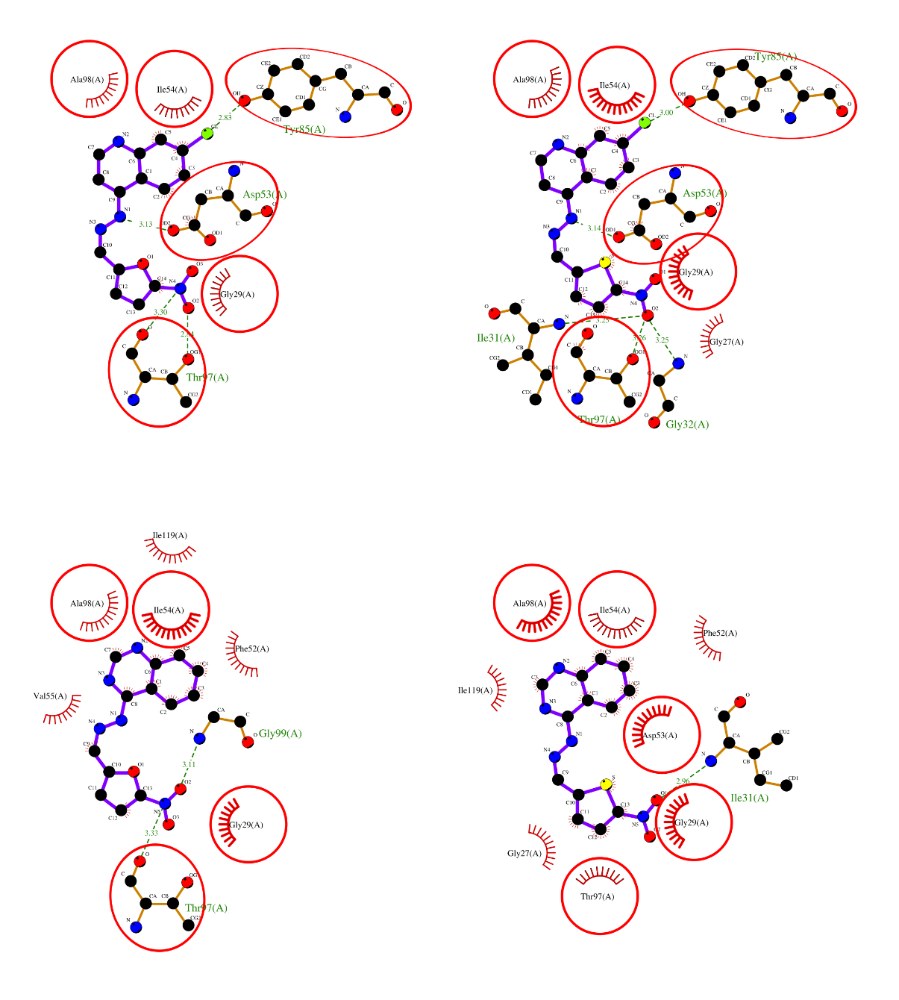

Figure S1. The Ligplot analysis for L-lactate dehydrogenase and ligand interactions. Ligands shown in magenta. Green dashed lines were illustrated hydrogen bonds.

